**VIRTUAL MOUSE:**

Computer vision is a field of study that focuses on enabling computers to interpret and understand digital images and video, similar to how humans do.

A virtual mouse involves using a camera to track the movement of a user's hand, and using that movement to control the position of the mouse cursor on the screen.

To build a virtual mouse, you will need to:

1.Set up a camera: You will need a camera to capture images of the user's hand movements. A webcam or a smartphone camera can be used for this purpose.

2.Track hand movements: You will need to use a computer vision library, such as OpenCV or TensorFlow, to track the position of the user's hand in real-time. This can be done by detecting the user's skin color or using deep learning algorithms to detect hand landmarks.

3.Map hand movements to cursor movements: Once you have tracked the position of the user's hand, you will need to map that movement to the position of the mouse cursor on the screen. This can be done using a simple mapping function.

4.Implement mouse clicks: You will also need to implement the ability to perform mouse clicks using hand gestures or buttons on the screen.

Here are the modules used in the code:

1.cv2: It stands for OpenCV, which is a library for computer vision and machine learning. It is used to read the video feed from the webcam and display to the output window.

2.numpy: It is a numerical computing library used to perform array operations in Python.It is used for numerical operations on images.

3.time: It is a module used to measure the execution time of the code. It is used to calculate the frame rate of the video feed.

4.pyautogui: It is a library used for automating keyboard and mouse actions in Python. It is used to move the mouse cursor and perform clicks on the screen.

5.Mediapipe: It is a machine learning framework used for building multimodal (e.g., video, audio) applied ML pipelines. It is used for hand detection and tracking.

6.HandTracking: It is a custom module created by the programmer for hand detection and tracking.It contains various fuctions, where the handDetector function is used to create a detector object that can detect the hand's position in the video feed, the findHands function of the detector object is then called on the image frame to detect the hand in the image, the findPosition function is used to get the position of the detected hand's landmarks and the fingersUp function is used to detect whether the fingers are up or down.

Output Screenshots:

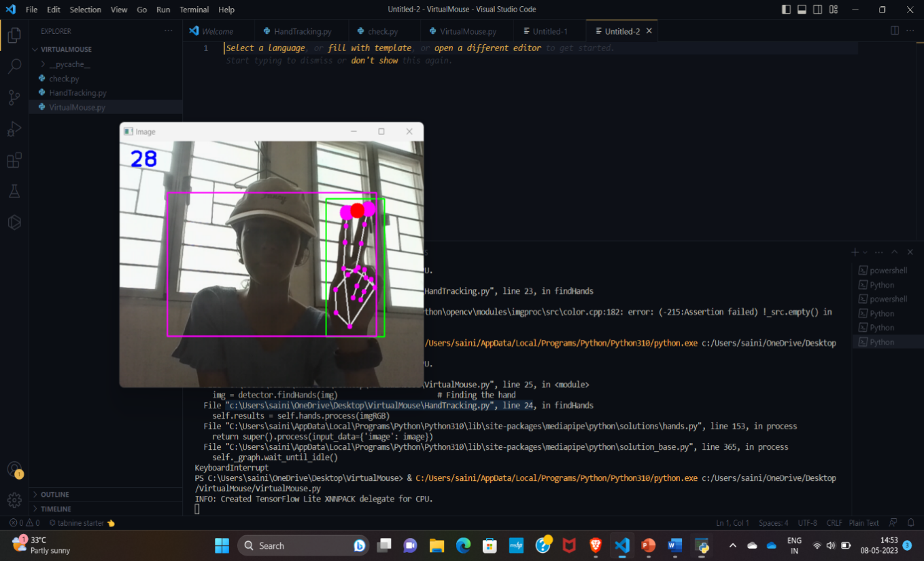

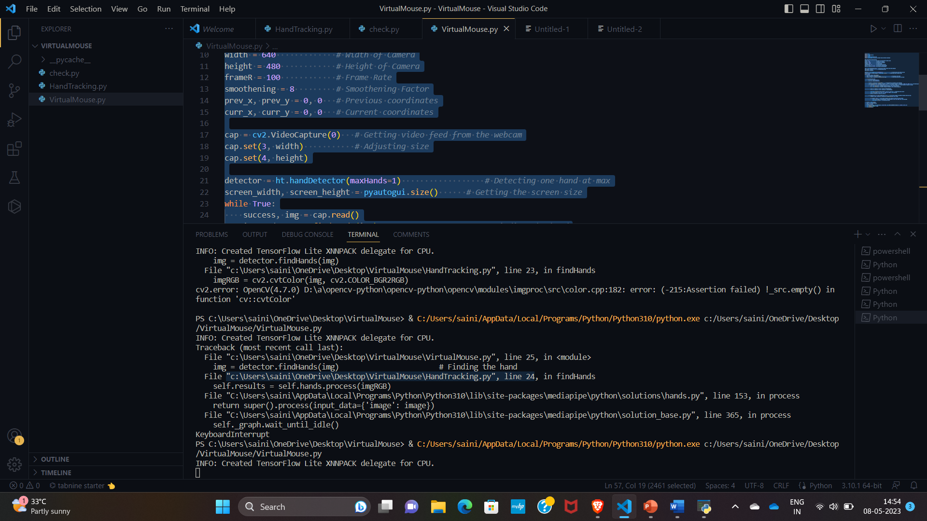

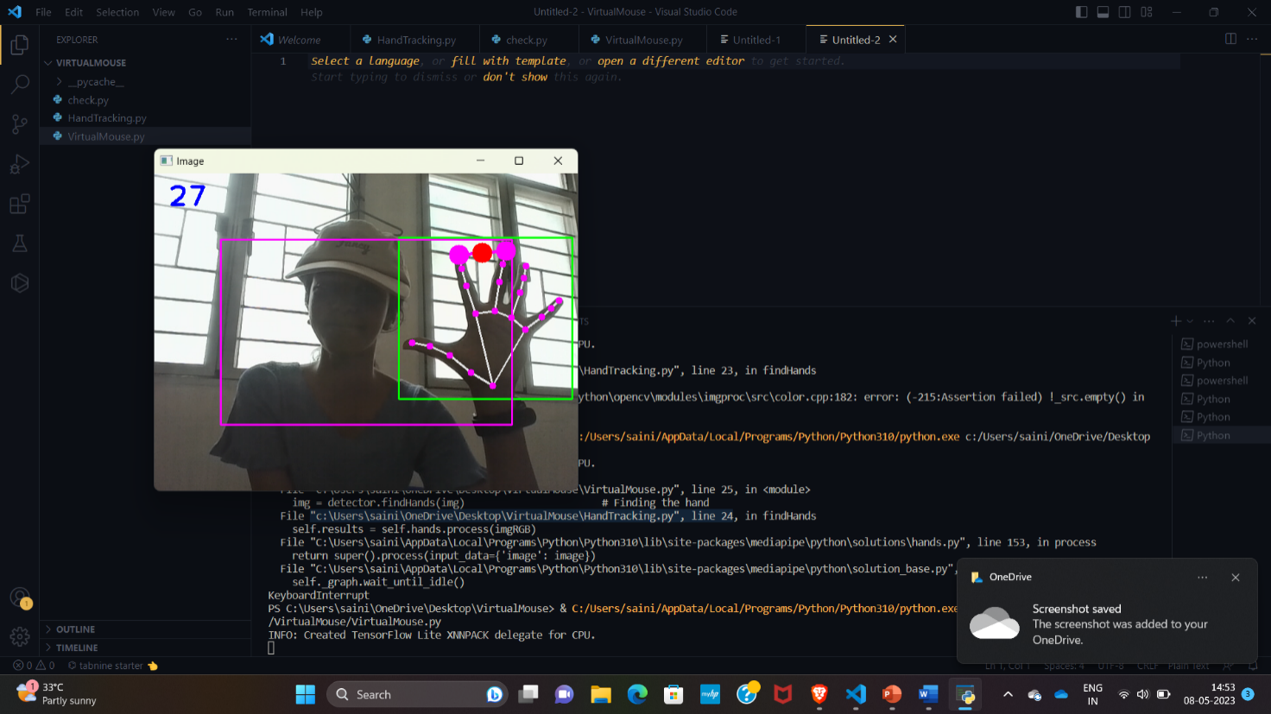

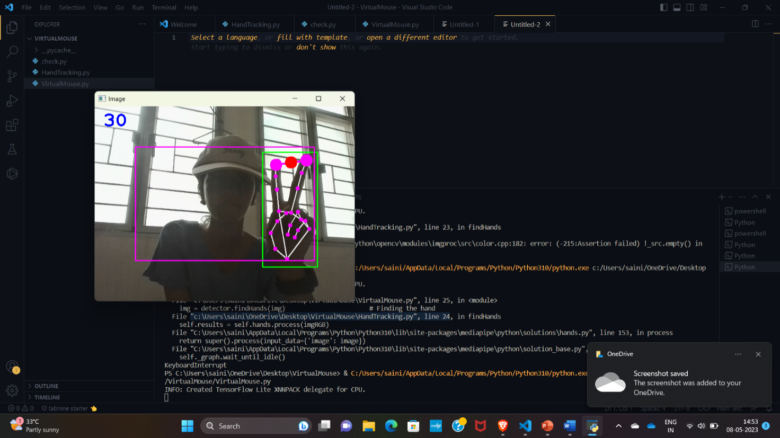

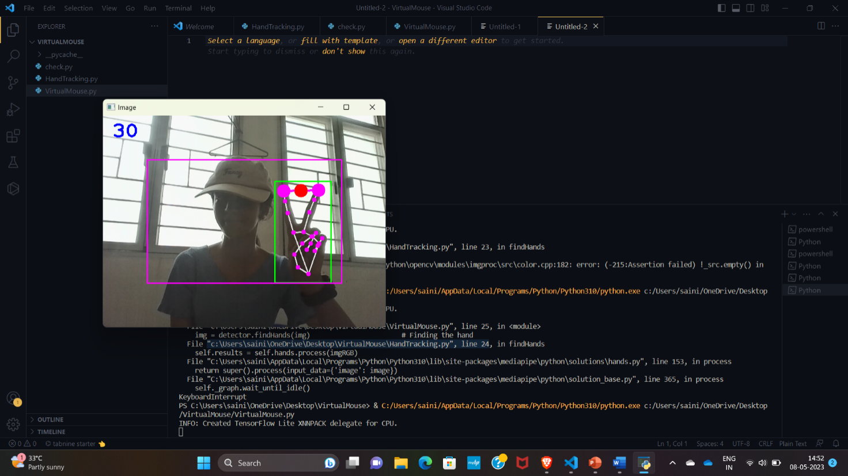

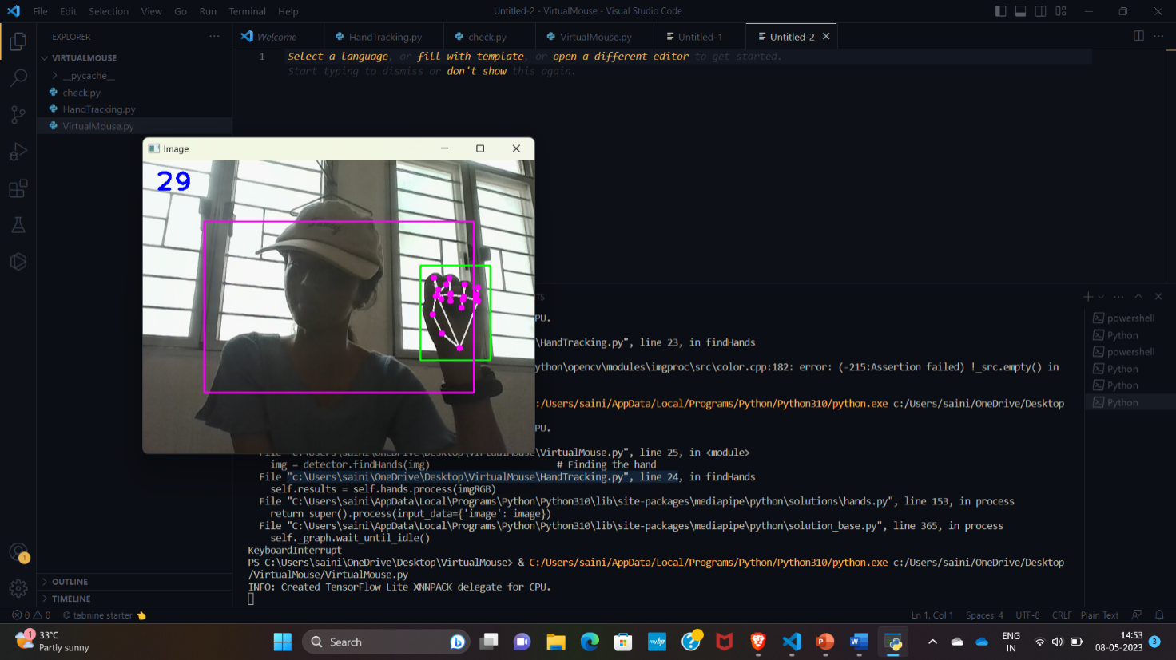

Group members:

1)Deepthi.I (22011103010)

2)Reddy Sai Nikhila (22011103036)

3)Meera Vanathi.M (22011103028)

4)Virgina Benadi.F (22011103064)